OBJECT ORIENTED PROGRAMMING With C++ CA

**Instructions:** Accomplish the following in C++. your are to work in groups of 4.

You have been asked to design a simple gambling system for your local casino. Due to the lack of funds you are expected to design a Console application.

**SECTION A**

For the card gambling system to work , you application needs the ability to display cards.

In this section build a program that receives two inputs from the user-- the card number and the card type-- and displayed the card on your console. This display **may** look like fig 1 below

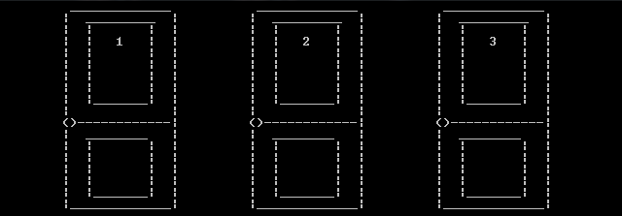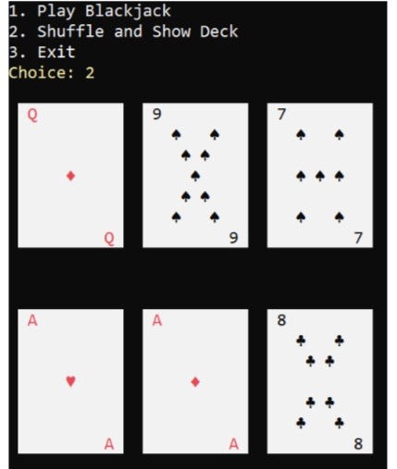

Fig 1

**SECTION B**

Thanks to your colleague’s success you have a fully functional card display system . Now using your friends system designed above you are expected to expand the system to accommodate a minimum of a single player and a maximum of 4 players.

Each player should be given 3 cards each including the PC(NPC or your computer).

Your program should track which player receives which card .

The card given to each player should be displayed on screen except the PC(NPC or your computer) cards.

**SECTION C**

If all went well you now have a system that can share and displayed the cards shared to the user.

Now using your group mates code from above implement the combinations in poker to determine a winner .

This system matches each individuals card with the PC to create combination. This combinations determine the winner . more details can be found online or check link

( <https://youtu.be/cNaUXwu4MzQ?si=iDB9Y_HbkQ0ZsWRa> )

**SECTION D**

with this you have developed a fully working poker system, now a casino can’t run with one card game now can it ?

In this section you are expected to use at least two of your friends code from above to develop or implement a card game of your design or that already exist.

GOOD LUCK